Name:S.Sadwik
id:2403A510F7 batch:06

SCHOOLOFCOMPUTER SCIENCE AND ARTIFICIAL INTELLIGENCE |  |  |  |  | DEPARTMENTOFCOMPUTER SCIENCE ENGINEERING
ProgramName:B. Tech |  |  |  | AssignmentType: Lab |  |  | AcademicYear:2025-2026
CourseCoordinatorName |  |  |  | Venkataramana Veeramsetty
Instructor(s)Name |  |  |  | 1. Dr. Mohammed Ali Shaik  2. Dr. T Sampath Kumar  3. Mr. S Naresh Kumar  4. Dr. V. Rajesh  5. Dr. Brij Kishore  6. Dr Pramoda Patro  7. Dr. Venkataramana  8. Dr. Ravi Chander  9. Dr. Jagjeeth Singh
CourseCode |  |  | 24CS002PC215 | CourseTitle |  | AI Assisted Coding
Year/Sem |  |  | II/I | Regulation |  | R24
DateandDay  of Assignment |  |  |  | Time(s)
Duration |  |  | 2 Hours | Applicableto  Batches
AssignmentNumber:3.3(Presentassignmentnumber)/24(Totalnumberofassignments)
 | Q.No. | Question |  |  |  |  |  | ExpectedTime  to complete
 | 1 | Lab 3: Prompt Engineering – Improving Prompts and Context Management  Lab Objectives:  - To understand how prompt structure and wording influence AI-generated code.  - To explore how context (like comments and function names) helps AI generate relevant output.  - To evaluate the quality and accuracy of code based on prompt clarity.  - To develop effective prompting strategies for AI-assisted programming.  Lab Outcomes (LOs):  After completing this lab, students will be able to:  - Generate Python code using Google Gemini in Google Colab.  - Analyze the effectiveness of code explanations and suggestions by Gemini.  - Set up and use Cursor AI for AI-powered coding assistance.  - Evaluate and refactor code using Cursor AI features.  - Compare AI tool behavior and code quality across different platforms.  Task Description#1  - Try 3 different prompts to generate a factorial function.  Expected Output#1  - Comparison of AI-generated code styles  Prompt:  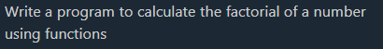  Code:  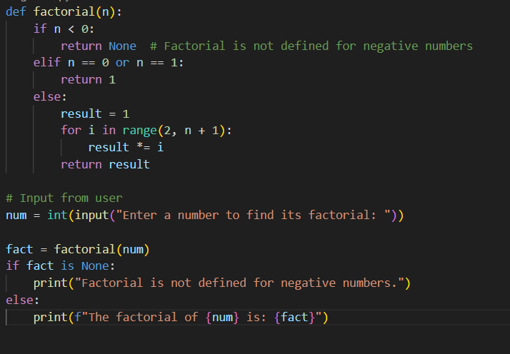  Output:  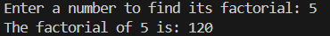  Prompt:  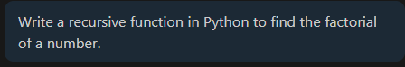  Code:  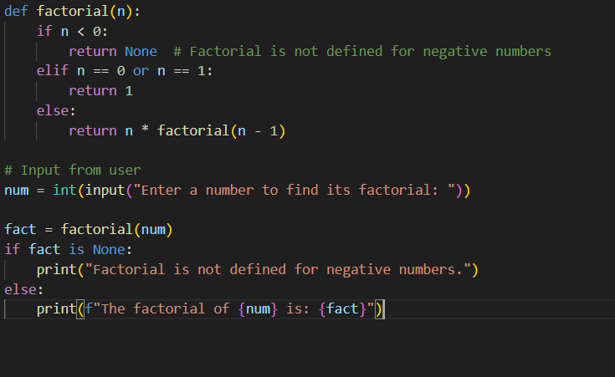  Output:  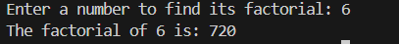  Prompt:  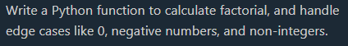  Code:  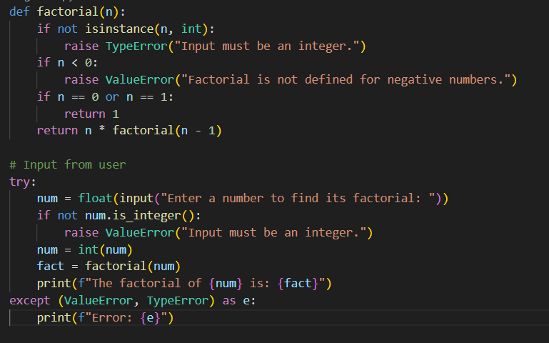  Output:  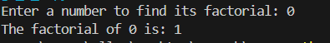  Task Description#2  - Provide a clear example input-output prompt to generate a sorting function.  Expected Output#2  - Functional sorting code from AI  Prompt:  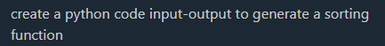  Code:  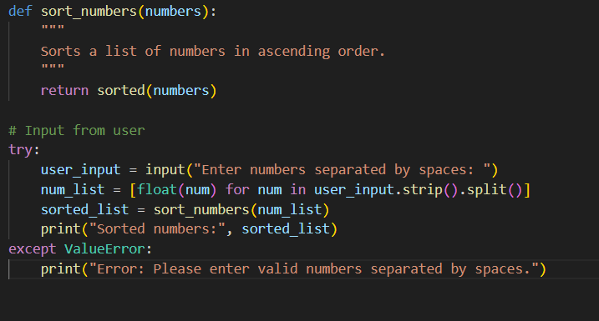  Output:  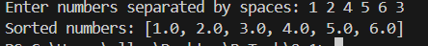  Task Description#3  - Start with the vague prompt “Generate python code to calculate power bill” and improve it step-by-step  Expected Output#3  - Enhanced AI output with clearer prompts  Prompt:  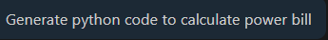  Code:  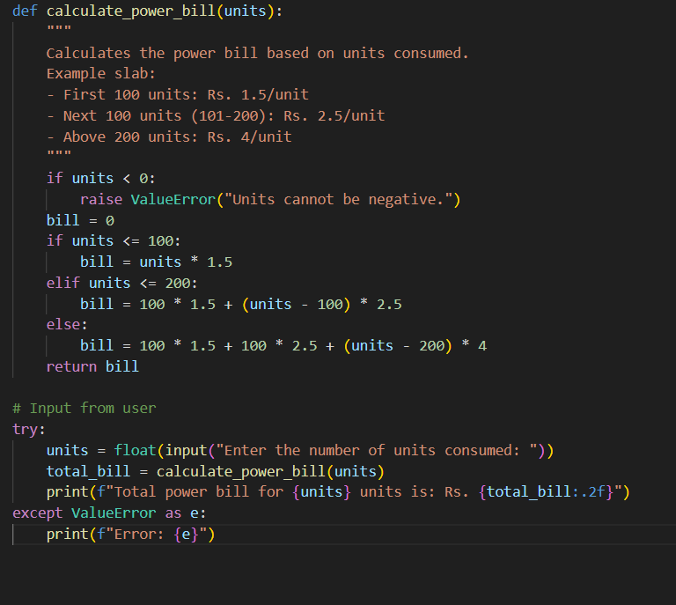  Output:  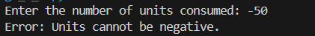  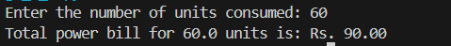  Task Description#4  - Write structured comments to help AI generate two linked functions (e.g., login_user() and register_user()).  Expected Output#4  - Consistent functions with shared logic  Prompt:  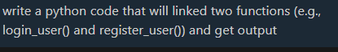  Code:  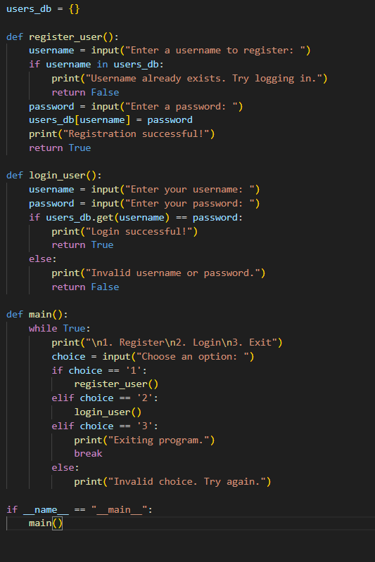  Output:  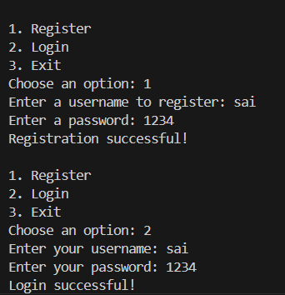  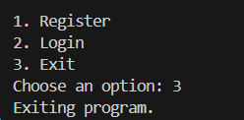  Task Description#5  - Analyzing Prompt Specificity: Improving Temperature Conversion Function with Clear Instructions  Expected Output#5  - Code quality difference analysis for various prompts  Prompt:  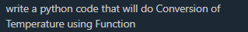  Code:  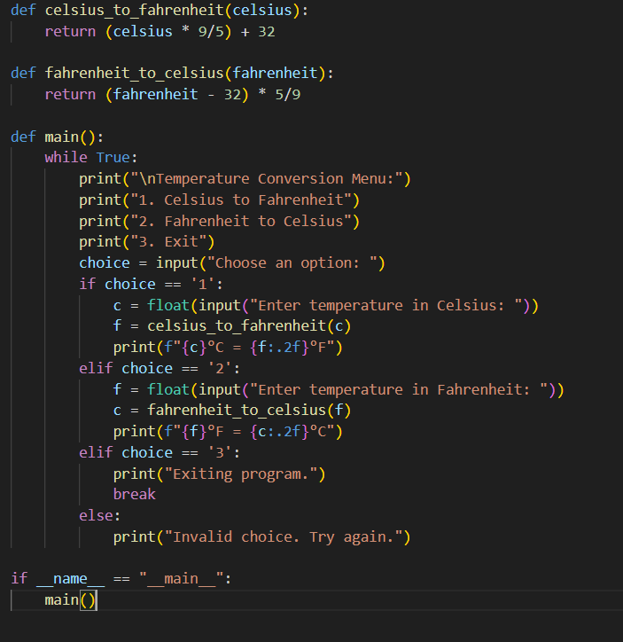  Output:  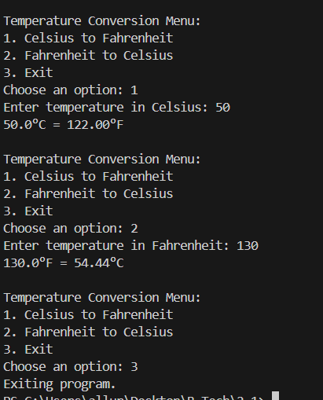  Note: Report should be submitted a word document for all tasks in a single document with prompts, comments & code explanation, and output and if required, screenshots  Evaluation Criteria: |  |  |  |  |  | 03.08.2025 EOD
  Criteria | Max Marks
  Factorial Function (Task#1) | 0.5
  Sorting Function (Task#2) | 0.5
  Vogue Vs. Specific Prompting (Task #3) | 0.5
  Linked Functions (Task #4) | 0.5
  Temperature Conversion Function (Task #5) | 0.5
  Total | 2.5 Marks

